Design and Implementation of a High-Efficiency Three-Phase Vienna Rectifier with Power Factor Correction and Three-Phase Inverter for Motor Speed Control Applications
Abstract:
This project presents the design and implementation of a high-efficiency power conversion system comprising a three-phase Vienna rectifier integrated with power factor correction (PFC) and a three-phase inverter, specifically tailored for advanced motor speed control applications. The Vienna rectifier topology is utilized for AC to DC conversion, offering significant advantages in terms of high power density, reduced conduction losses, and the capability to achieve near-unity power factor. Digital control strategies, such as sinusoidal current control and voltage-oriented control, are applied to minimize input current harmonics and optimize power quality at the rectifier's AC side. The rectified DC output is then supplied to a three-phase voltage source inverter (VSI), which enables precise and efficient control of motor speed and torque through pulse-width modulation (PWM) techniques. The proposed system is designed and simulated using MATLAB/Simulink, and the key performance parameters—such as input power factor, total harmonic distortion (THD), DC bus voltage stability, and motor efficiency—are analyzed. Experimental validation is performed on a laboratory prototype to demonstrate the effectiveness of the overall system in real-world industrial scenarios. Results show significant improvements in power quality, energy efficiency, and adaptability for motor drive applications, making the system suitable for integration in high-performance industrial automation and variable speed drive systems.
Block Diagram:
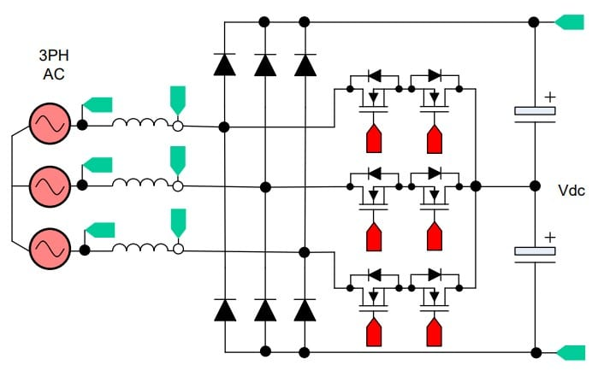
Fig. Three Phase Vienna Rectifier with Power Factor Correction
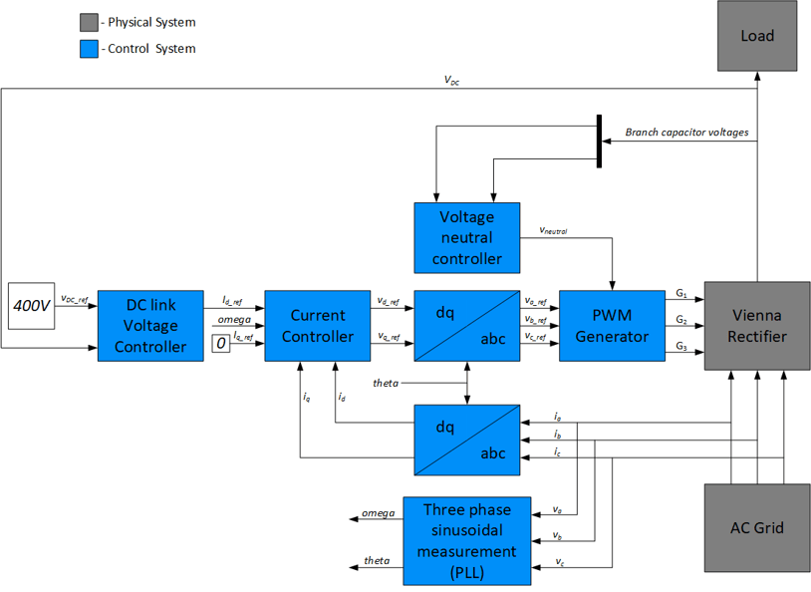
Fig 2. Closed Loop PID Attenuator for PWM Generation
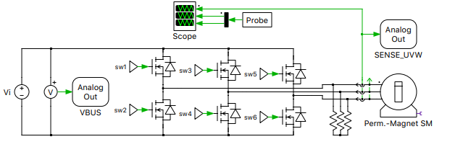
Fig 3. Three Phase Motor Driver

